**Geolift Platform: Step by step actions**

**Design Experiment**

Step1:Data load and specify variables

* Upload data (csv file)
* Define outcome variable column
  + Drop-down: select which column is target outcome variable (usually conversions)
* Define location ID column
  + Drop-down: select which column contains locations/DMAs
* Define Date column
  + Drop-down: select which column is date variable
* Define Date format
  + Drop-down: select which data format is used for date column e.g., yyyy-mm-dd

Click “Upload data” button to ingest data

Step1a: Visualization of the data

* After uploading data (clicking button “Upload data”), on the right side of the screen, we want to display
  + 1 tab shows raw dataset
  + 1 tab shows trend plots by DMAs, x = date, y = target variable (conversions)
    - Display top 10 DMAs, depending on the space

Step 2: Configure Analysis

* Describe the type of test (select one)
  + Holdout: Test decreasing or eliminating spend in an existing channel
  + Scale : Test increasing spend on an existing channel or adding new channel
* Approximate Cost per Incremental Conversion (optional): (typically from MMM or previous lift experiments)
* Budget (optional): the maximum budget available for a GeoLift test. If no budget is provided, all market selections will be analyzed by the algorithm
* Lenth of the study (days or weeks, depending on the date variable in the uploaded data)
  + User inputs numbers
* Effect size (%): (type one number)
  + A percent change in the dependent variable between the test and control groups that we will use in simulations while finding groups
* Markets required to be included (optional) : (
  + User inserts the name of DMAs, but pop-up the DMAs based on the column in the uploaded data). This can be one or multiple DMAs
* Markets excluded (optional):
  + User inserts the name of DMAs, but pop-up the DMAs based on the column in the uploaded data). This can be one or multiple DMAs
* Desired number of locations in test group
  + User inserts the numbers

After the user inputs information in Step 1 and Step 2, click “Generate Test Markets” button to run the model in R

Step 3: Display the selected DMAs

* Display the output result generated by model in R, which can be a csv file.

Output file example:

* Display the plot generated in R

Plot example:

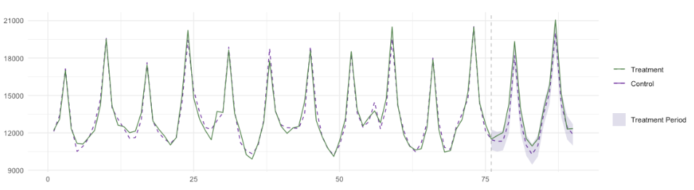

Test-Period Period

Pre-Test Period

* If possible, show different plots when clicking the different location cells (column C) in the output file

Step 4: Select the best locations and display plan recommendation

* Select the best locations from the drop-down menu which includes the location ranking (column C) of all rows
* After the best locations (one row from the output file) are selected, display information from the output file:
  + Names of all locations (column C, separated by comma, remove IDs)
  + Recommended test period (column E)
  + Proportion (%) of total conversions (column K)
  + Average minimum detective effect (column J)

**Analyze Experiment**

Step1: Data load and specify variables

* Upload data (csv file)
* Define outcome variable column
  + Drop-down: select which column is target outcome variable
* Define location ID column
  + Drop-down: select which column contains location/DMA information
* Define Date column
  + Drop-down: select which column is variable
* Define Date format
  + Drop-down: select which data format was used for date column e.g., yyyy-mm-dd

Click “Upload data” button to ingest data

Step1a: Visualization of the data

* After uploading data (clicking button “upload data”), on the right side of the screen, we want to display
  + 1 tab shows raw dataset (date, locations and KPIs/conversions)
  + 1 tab shows trend plots by DMAs, x = date, y = target variable (conversions)
    - Display top 10 DMAs, depending on the space

Step 2: Configure analysis

* Select test start and end period by using calendar
* Select/Type locations of test groups
* Select outcome variable type by clicking the following
  + I reduced spend in these locations
  + I increased spend in these locations

Click “Analyze experiment” button

Step 3: Display the results of analysis

* After clicking the “Analyze experiment” button, display the following from the output result of analysis from R (this can be csv file)
  + Incremental conversion lift
  + Percent lift %
  + Statistical significant : Yes or No ( this is based on the P-value from the output from R)
* Display a plot with three bars
  + control/modeled group conversions
  + actual test group conversions
  + absolute lift (difference between control and test)
* Display the plot generated in R

Plot example:

Test-Period Period

Pre-Test Period